Breast density based segmentation

Attention unet
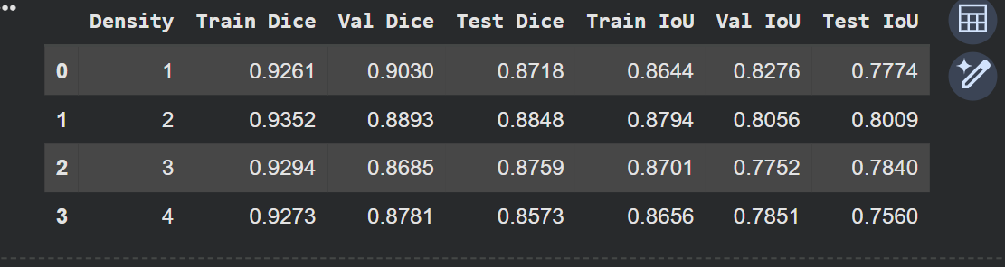

Segformer
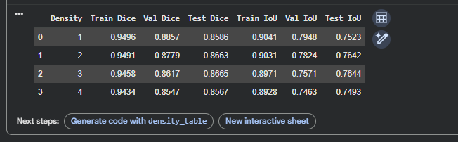

DeepLabV3+
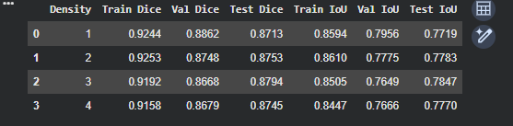

SwinUnet
